Harmonic and Pizzicato Data Processing
In the last section, we looked at data of the Kutz #100 in lower frequencies, specifically looking at bowed open strings and bowed scales. There wasn’t a lot of high frequency action, as expected, as one hypothesis of this experiment is that high frequency content will be richer in higher quality instruments. In this section, we’ll examine the Kutz #100’s upper range by looking at the bowed open-string harmonics on each string. The effect of articulations such as pizzicato on the frequency profile will also be observed.
The FFT of the bowed open-string G harmonic can be seen below.
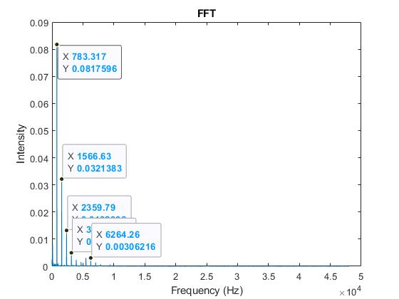
The first and strongest peak is seen at the fourth harmonic. This will be a common trend as we look at the harmonics. Following suit of the non-harmonic open strings, the intensities of the harmonics decay exponentially as frequency increases. Since this is the bowed open string harmonic, the sounding pitch is two octaves above the fundamental; our analysis shows that the strongest peak in the G harmonic on the Kutz #100 shows up in the 4th harmonic, or four octaves higher than the fundamental. This is not in line with what we hear, meaning this may be one of our quality measures for a violin—the strongest harmonic should be in line with what we hear. For this open-string harmonic, the upper frequency range is very inactive.
Next, we’ll look at the open-string E harmonic. The FFT can be seen below.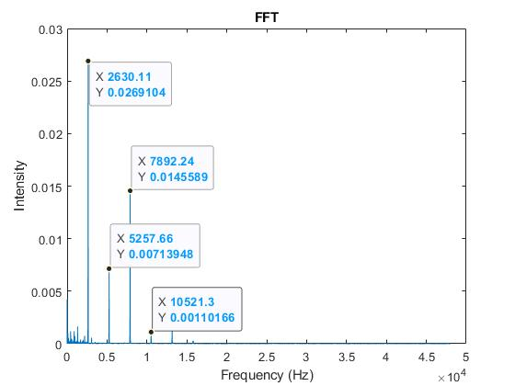
Again, the first and strongest peak is seen at the fourth harmonic. Note that the peak intensity for the first peak is 4 times weaker than the peak intensity for the first peak on the G harmonic. The harmonics after the first peak also generally follow an exponential decay—the only difference is that this time, there is activity in the super-sonic range. Any frequencies greater than 20 kHz are classified as super-sonic, as they are beyond what is widely considered the limit of the human hearing range. The FFT of the super-sonic range for this recording can be seen below.
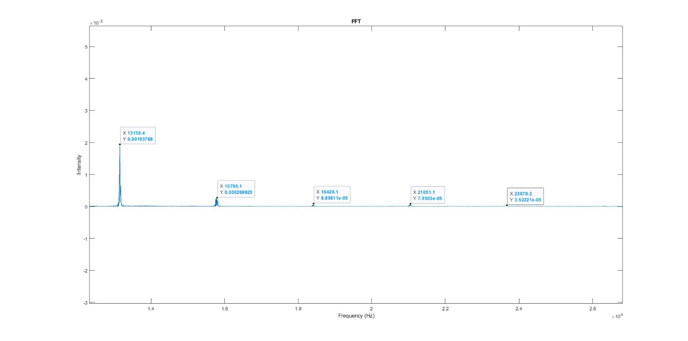
This is very promising, as it confirms that there are super-sonic frequencies that are detectable, even on cheap violins. This means that we can compare the super-sonic range on cheap violins against more expensive instruments and see if any patterns can be detected. While the peaks have a very small magnitude, they are still detectable relative to the rest of the data.
Next, we looked at the pizzicato data. The FFT of the open G pizzicato can be seen below.
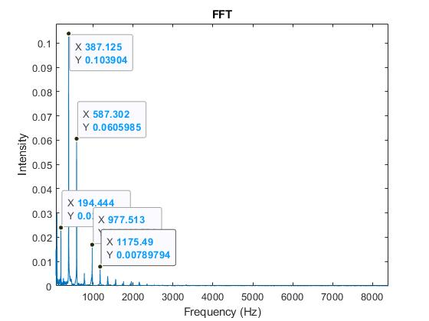
For this recording, the strongest peak occurs at the second harmonic, although the fundamental is significantly more present than in the past, albeit still overshadowed by the upper harmonics. The peak intensity is also 25% stronger than the peak intensity in the bowed open string and bowed harmonic open string. This makes sense, as the intensity of the peak is a measure of how much energy that frequency carries—since a pizzicato has a sharp attack, there is a large concentration of energy in the recording, yielding a significantly higher peak in this section as compared to others.
The main point of looking at the open-string harmonic recordings was to determine if there is any high frequency action, which there is in places that we would expect it to be. The purpose of examining the pizzicato recordings was to make sense of the intensities, and ensure that our data processing methods are consistent with what we would expect.

